BioInnovation Africa
Call for expressions of interest
The project invites ‘expressions of interest’ from business and business organizations interested in partnering with the Deutsche Gesellschaft für Internationale Zusammenarbeit (GIZ) GmbH to develop or scale up supply chains that are based on African biodiversity and respect the UNCTAD BioTrade principles.
About GIZ and the BioInnovation Africa project
GIZ is a state owned organization. We work worldwide in the field of international cooperation for sustainable development. We offer the experience, the regional and technical know-how of GIZ in the global market and provide international clients with expertise in terms of economic and result-oriented services.

Through the BioInnovation Africa project, which is commissioned by the German Federal Ministry for Economic Cooperation and Development (BMZ), the GIZ aims to foster equitable European-African business partnerships that contribute to biodiversity conservation and sustainable use in Cameroon, Madagascar, Namibia or South Africa.

The project intends to do so by encouraging and supporting the private sector to invest in Africa and establish long-term partnerships for biodiversity-based businesses.

Its objectives are:
- ABS regulatory compliance – implementing the Nagoya Protocol on Access and Benefit Sharing (ABS) of the Convention on Biological Diversity.
- Ecological sustainability – foster R&D and sourcing schemes that respect people and support biodiversity conservation.
- Innovation for new products and jobs – promoting technology transfer, long term business partnerships for a reliable supply of natural ingredients and better products.
- Advocacy – showcasing successful and sustainable North-South business partnerships as “proof of principle” will help to increasingly integrate BioTrade and ABS principles in cooperation portfolios.
The projects intervention areas are defined as follows:
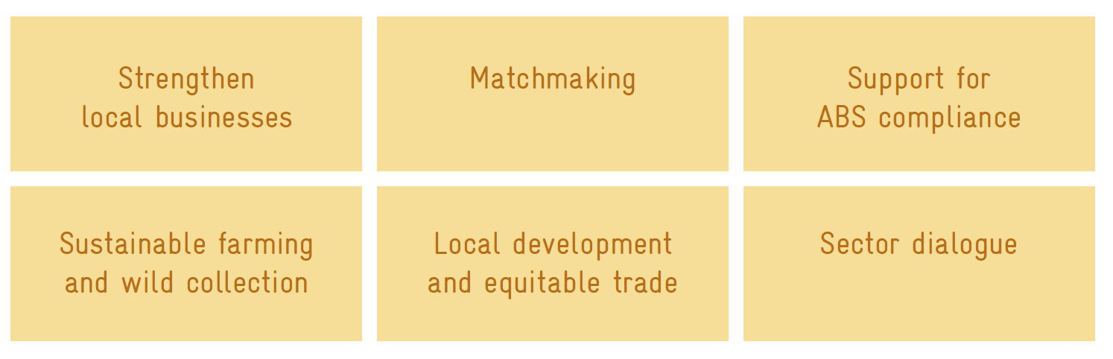

The implementation of the project is supported by GeoMedia GmbH and the Union for Ethical BioTrade (UEBT). The latter mentioned in particular will facilitate business engagement and provide guidance on its sourcing standards.

What are we looking for?
GIZ is looking for partners with concrete and economically viable proposals to advance business opportunities in Africa, in line with the objectives of the BioInnovation Africa project and UNCTAD BioTrade principles.

The project is particularly interested in proposals that seek to:
- develop new ingredients or new applications of ingredients derived from African biodiversity in sectors such as food, cosmetics and pharmaceuticals;
- strengthen existing supply chains for national markets or export to Europe;
- advance compliance (including regularization) with ABS rules and regulations in Africa; and
- render concrete impacts within a period of two years.

Please note that proposals can only be selected if interventions:
- would not come about without GIZ support (subsidiarity);
- are not required by law;
- bring measurable changes over a predefined duration;
- make good business sense, but would not be the only / exclusive business activity of the proposing entity;
- have a coherent design, realistic objectives and activities and appropriate cost-benefit ratio; and
- help to create, strengthen or consolidate existing structures to ensure the sustainability of results and changes achieved.

Who can express interest?
BioInnovation Africa invites businesses and business organizations that are committed to:
- sustainable sourcing of biodiversity-based resources and natural ingredients from Cameroon, Madagascar, Namibia, South Africa;
- advancing UNCTAD BioTrade principles and practices in supply chains;
- partnerships with resource providers that contribute to local development;
- supporting biodiversity conservation and its sustainable use;
- compliance with applicable rules and regulations on access and benefit sharing (ABS);
- transparent and open dialogue with project partners; and
- actively contributing to project activities, for instance through co-investments or technology and knowledge transfer.

The following preconditions apply. The organization must:
- be legally constituted;
- be registered in a European country or in either one of the following African countries: Cameroon, Madagascar, Namibia or South Africa and have proven business link with European companies;
- dispose an audited annual financial statement;
- have an annual turnover of at least EUR 500,000 and a minimum of five employees (PLEASE NOTE: this criteria only applies to European companies);
- have sufficient economic solvency and liquidity to make necessary own contributions (monetary and in-kind); and
- have or can mobilize staff resources and specialist qualifications required to manage the project as proposed.

What are the cooperation modalities?
GIZ through BioInnovation Africa is seeking to collaborate with European and African business partnerships for value chains starting in one of the four African partner countries. All project partners are expected to work jointly within the project and actively contribute to the mutually identified activities.
Beneficiaries of the joint activities may include, but are not restricted to farmers, indigenous people and local communities, local SMEs and public research institutions. Collaboration modalities are tailor made and demand driven, depending on the local context. They may include technical and financial support to local actors at various steps of the supply chain to increase product quality and strengthen the local bio trade sector.

A wide portfolio of project support services can be considered and jointly defined. Examples of possible activities include training of local suppliers, consultations with local supplier communities, development of biodiversity management plans, guidance for ABS compliance, facilitation of ABS negotiations, match-making and sector round-tables and dialogues.

What is the application and implementation process?

How to get more information and how to apply:
- We invite eligible, interested companies to submit their expression of interest via email to bioinnovation@giz.de until Friday, 6th December 2019 COB.

- The format for expressions of interest, selection criteria and further background information are available for download at the following link: www.abs-initiative.info/bioinnovation
- Interested organizations can contact us via email (bioinnovation@giz.de) or phone (+49 228 44 60 - 1991) for any additional questions.

- The GIZ ensures, that the information provided in the Expression of Interest will not be made public.

